

INTRODUCTION

VEHICLE MANAGEMENT SYSTEM USING SALESFORCE

1. Overview:

Administrator should be able to create all base data including Semester, candidate, course and lecturer. Lecturer should have the ability to create internal results, dean, who is one of the lecturers, should be the only one with ability to update internal results, re-evaluation can be initialized by candidate for all internal results. Now only dean can update the marks after re-evaluation.

1. Sales force:

Sales force is your customer success platform, designed to help you sell, service, market, analyze, and connect with your customers.



So what does that really mean? Well before sales force your contacts emails follow-up tasks and prospective deals this.

1. Purpose:
   * Single view of the customer for the cross functional insight and reporting.
   * Dashboards that visually showcase data in action.
   * Customer-centric automation.
   * Proactive service.
   * Optimized processes.
   * Simplified collaboration.



1. Problem definition & design thinking:

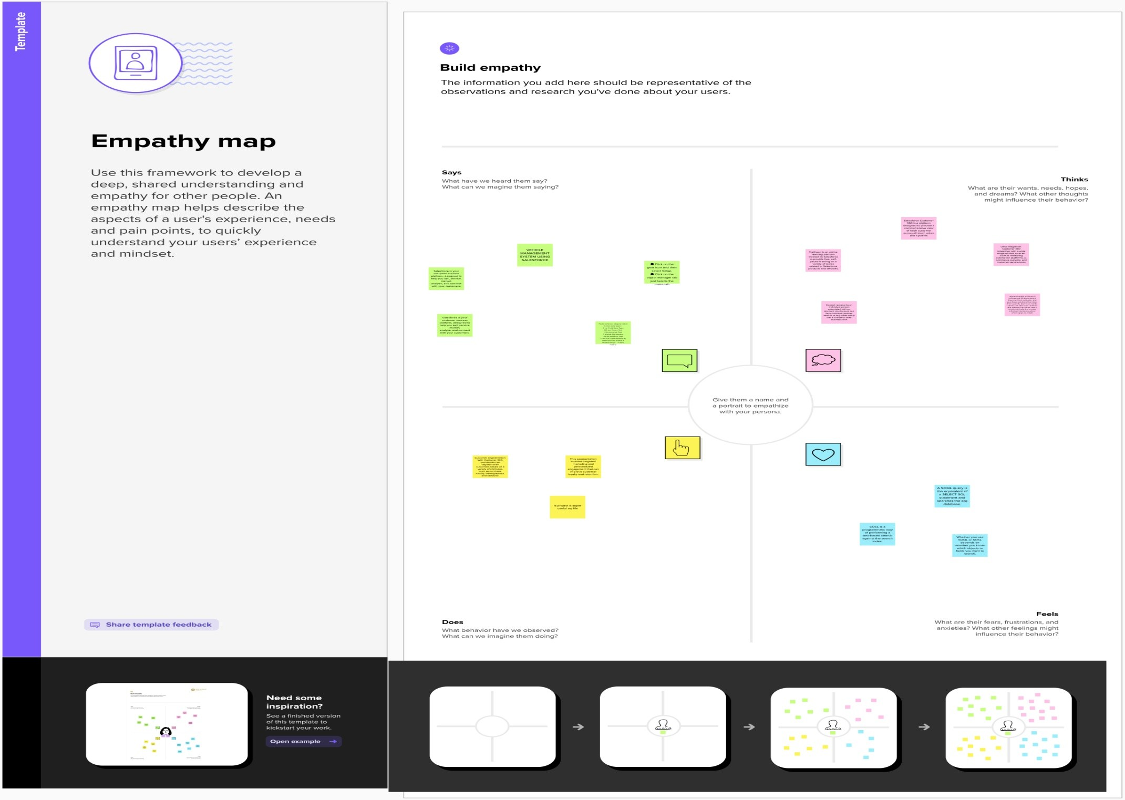



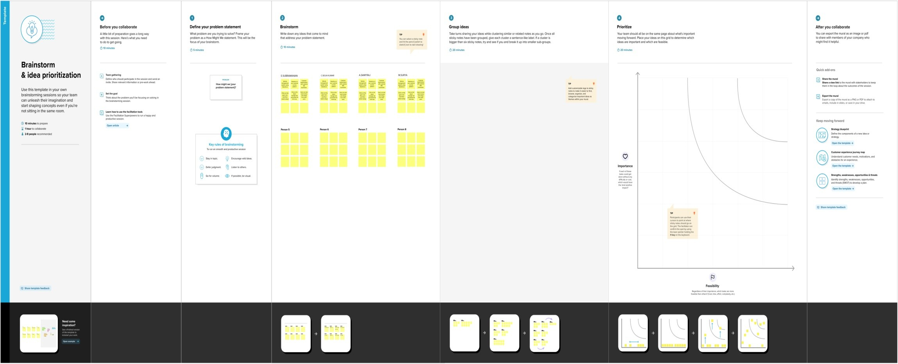

* 1. Y7

|  |  |  |  |  |  |  |
| --- | --- | --- | --- | --- | --- | --- |
| Object Name | Fields in the Object | | | | | |
| Vehicles |  | Fields Names | Data Types | |  | |
| Customer Name | Text | |
| Vehicle Type | Number | |
| 2WHEELERS | Picklist | |
| 4WHEELERS | Picklist | |
| Vehicle Name | Text | |
| Vehicle No | Text | |
| Classic No | Text | |
| Colour | Text | |
| Body type | Text | |
| Vehicle Includes | Multi Picklist | |
| Condition | Picklist | |
| Mileage | Text | |
| Seats | Number | |
| Start Date | Date/Time | |
| End Date | Date/Time | |
| Opportunity | Lookup | |
| Customer Mobile  No | Number | |
| Driver |  | Field | | Data Type | |  |
| Driver Name | | Text | |  |
| Licence No | | Text | |  |
| Mobile No | | Number | |  |
| Fair Per Hour | | Text | |  |
| Vehicle | | Lookup | |  |



1. 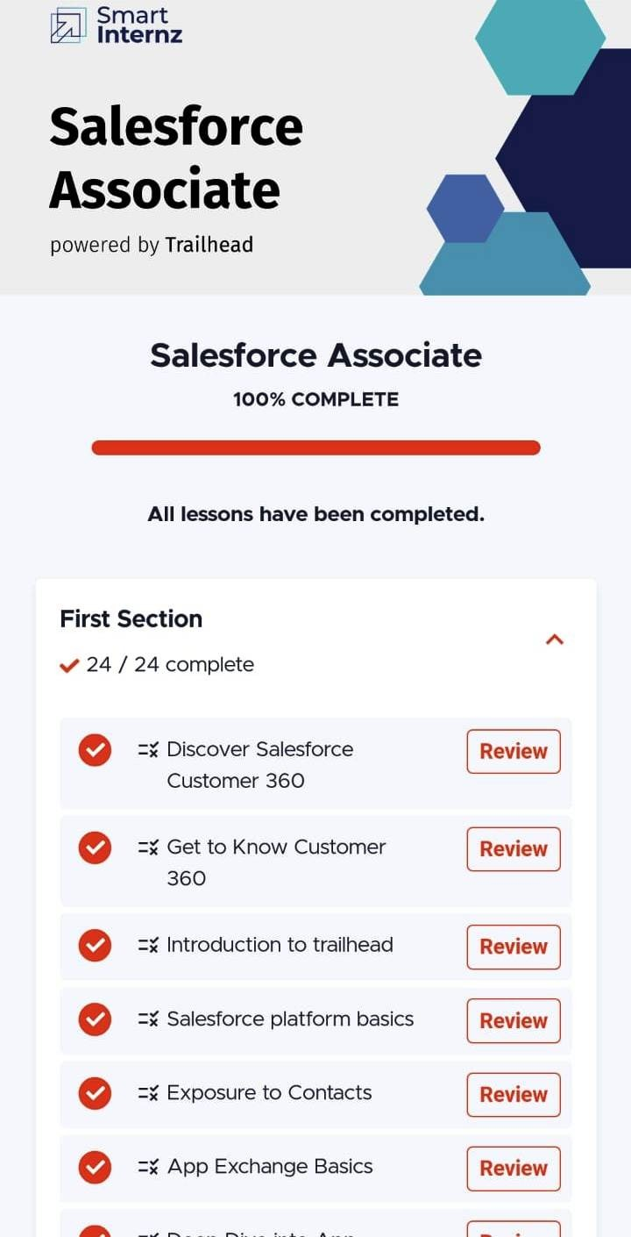Activity & screenshot:



1. Trailhead profile public URL:

TEAM LEADER: <https://trailblazer.me/id/selvc3>

TEAM MEMBER 1: <https://trailblazer.me/id/samya72>

TEAM MEMBER 2: <http://trailblazer.me/id/ciboy1>

TEAM MEMBER 3: <http://trailblazer.me/id/massmani3>

PROJECT REPORT TEMPLATE

1. Advantages:
   * It allows for more effective sales and marketing.
   * It can speed up the sales conversion process.
   * It increases staff productivity, lowers time costs and boosts morale.
   * It enables widely dispersed teams to work closely.



* + Can improve customer loyalty through exceptional experience.

1. Disadvantages:

* Staff over- reliance on CRM may diminish customer loyalty through a bad experience.
* Security concerns associate with centralized data.
* The excess initial time and productivity cost of implementation.
* It may not suit every business.

1. Applications:

* Align sales and marketing.
* Increase sales productivity.
* Build better customer relations.



1. Conclusion:

Customer relationship management is a business strategy that enables a business organization to maximize revenue, customer satisfaction, profitability through strategic mobilization, organization, and management of customer’s interests and desires.

1. Future scope:

Customer will become a company’s best sales reps through superior products and services as well as customer-oriented messaging. The future of CRM is more than just the future of customer relationship management software. It is really the future of business.